**Meeting 12/3 Notes:**

**Agenda:**

1. **Schedule next meeting**
2. **Tools & Collaboration discussion - Some people are using Word, others are using Google Docs. Using different tools strains collaboration.**
   1. **Seek agreement on tools**
   2. **Assign document alignment tasks - Dajiba**
3. **Plan to perform group brainstorming during the next meeting**
4. **Add additional material**
   1. **Abstract - Dajiba (?)**
   2. **Introduction (~1 page) and merge in the store owner interview analysis - Daniel**
   3. **Needfinding (data inventory) - Abhijeet**

**Meeting 11/30 Notes:**

**Agenda:**

1. **Schedule next meeting**
2. **Review current document and assign work sections for Sunday’s submission:**
   1. **Fix abstract formatting & fix last sentence - Daniel**
   2. **Flesh out introduction - Dajiba**
   3. **Add details to the two interview sections explaining why interviews are the best approach for these two separate user groups - Myles**
   4. **Add data inventory section to Customer Needfinding Results - Abhi**
   5. **Write Professional Shopper Needfinding Results (including potentially fabricating interviews) - Dajiba**
   6. **Write Store Manager Needfinding Results (including potentially fabricating/changing interviews) - Daniel**
3. **Review the completed needfinding exercises**
4. **Review the completed individual brainstorming**
5. **Perform group brainstorming**

**Notes:**

**Meeting 11/28 Notes**

1. **Need to document the reason behind using interviews with two types of users**
2. **Need 1 real instacart interview (before the next meeting)**
3. **Need 1 real grocery store interview (before the next meeting)**
4. **Can move on to design alternatives for regular customers**
5. **Everyone should do individual brainstorming based on the results of needfinding 1 before the next meeting.**

**Meeting 11/25 Notes**

**Abhijeet to submit all future iterations**

**Meeting 11/20 Notes**

**Next steps:**

1. **Dajiba will place an order with Instacart and basically ambush the professional shopper who comes to deliver his groceries.**
2. **Dajiba will ask the shopper if he has any colleagues who would be willing to answer similar questions.**
3. **Myles will call instacart corporate and the Atlanta office**
4. **Each of us should try to visit a store to speak to a manager**
5. **Dajiba to send email to TAs to confirm if we need to use distinct need finding methods - email Send(11/21)**

**Complete next steps by Sunday!**

**Project M Check-In 1:  
Abhijeet Chavan: achavan8@gatech.edu,  
Myles Lefkovitz: mlefkovitz@gatech.edu  
Dajiba Patil: dpatil32@gatech.edu,  
Daniel Reeves: danielreeves@gatech.edu**Abstract. We all are busy with our lives and with that busyness we have an important task to do “shopping”. Shopping must be less strenuous and quick, without wasting time and energy. As such, we are designing an interface which can take shopping list and store name as inputs and output the shortest path to shop.

**(dreeves) Abstract addendum:** This project focuses on the task of a user going to a store to shop for items. Online shopping notwithstanding, the current user experience can be less than ideal for shoppers going into a new physical store to shop for items and this project aims to improve that experience for both novice and veteran shoppers alike.

Need finding Plan 1  
As part of the need finding plan1, we are planning to conduct survey to collect broad statistics in terms of demographics, context of operation, time availability, time spent and pre-planning etc. We are still in process of developing the survey questions however following is the draft version of the same.  
User Profile  
1. Select your age?  
2. Select your gender?  
3. Select your profession  
a. student, working professional, business  
4. Whom do you shop for?  
a. Self, Kids, Business, Charity  
Schedule  
5. When do you normally go shopping?  
a. Weekdays or Weekends, rush hours, closing hours  
6. How much time do you have for shopping?  
7. How much time do you spend on shopping?  
8. How often do you plan before you shop?  
  
Context  
1. Is there any dependency for shopping, such as going to office or dropping kids to school or school to visit?   
2. Do you multi-task while shopping?  
Purpose  
3. Do you shop for specific things?  
4. How easy it is to find items when you shop?  
5. Do you always find all the items in the first go?  
6. How many times do you rely on the shopping boards for your shopping?  
7. Do you plan your shopping based on display boards?  
8. What items do you think are easy to find?  
a. General Goods/Groceries, Hardware Tools, Electronics, Clothing  
9. What stores do you find easy for shopping and why?  
Need finding Plan 2  
Store Managers are important component of this interface. And as such, it's very important to take their consent in terms sharing some key business-related information such as store locations, store size, store layout and product placement in aisle and bins. This information is crucial at times as it might impact the business strategy in terms of sales, forecasts and competition. Furthermore, protecting the above information from its competitor also forms one of the requirement for this interface. To unfold the above mystery, we are planning to interview the Store Managers as part of our need finding exercise. Secondly, we would also interview the shoppers to understand their perspective. As noted earlier we are still in process of finalizing our plan of approach but here are draft questions that we would like to ask the Store Managers.  
Interview Questions for Store Managers  
10. How many dedicated staff do you have to help customer find the items?   
11. How many hours do you think your staff dedicate helping customers find the items?  
12. How interested are you in collaborating with third parties to help your customer find the items   
13. Will you be ready to share the store layout and item's bay location with these third parties

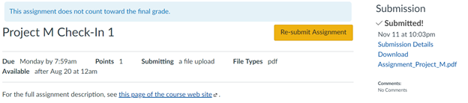

**11/13/18 Meeting Notes:**

**Goals:**

1. **Plan the work that needs to be done**
2. **Divide the work between the teammates**
3. **Determine a timeline**

**Concepts:**

1. **3 user groups**
   1. **Casual users**
   2. **Professional shoppers (Instacart)**
   3. **Store owners**
2. **Needfinding outcome goals - Casual users:**
   1. **Find shopping difficult, would like to locate products more easily**
3. **Needfinding outcome goals - Professional shoppers:**
   1. **Often visits different stores and frequently shops for different products**
   2. **Doesn’t often know how to find these products and often wastes times looking for them**
   3. **Specific shopping lists already defined**
4. **Needfinding outcome goals - Store owners:**
   1. **Unwilling to share information about their stores**
   2. **Unwilling to share information about the locations of their products within their stores to a 3rd party**
   3. **Do recognize that shoppers have issues finding products within their stores**
   4. **Would prefer to build their own system that they maintain and update to control the experience of their customers**
   5. **Would be interested in a device (like an iPad) for customers**
5. **Interface Ideas:**
   1. **Smartphone App for users (casual and professional shoppers)**
   2. **Chromebook/iPad owned by stores and distributed to shoppers at a particular shop**
   3. **Incentivize users for mapping out stores by having app running on their own smartphone while they shop (earn points, coupons, etc) and mapping out items themselves for further incentives.**
      1. **Cuts out need for separate hardware/store permissions.**

**################################################################**

11/14/2018: Abhijeet Survey Questions

1. Whom do you shop for?

a. Family

b. Business

c. Organization

d. Other __________________

2. How much time do you have for shopping? _____________ mins

3. On an average, how many items do you purchase in a single shopping trip

a. Less than 5

b. 6 to 10 items

c. 11 to 15 items

d. More than 15 items

4. Does your shopping list change on every shopping trip?

a. Significantly Changes

b. Changes

c. Somewhat Changes

d. Not at all

5. How satisfied you are with your current shopping experience?

a. Extremely Satisfied

b. Satisfied

c. Neutral

d. Not Satisfied

6. What things would enhance your shopping experience?

a. Shopping List

b. In-Store Navigation

c. Product Search

d. Other ________________________

7. What would best help you to find a product in the store?

a. Aisle Dashboards

b. Store Personnel

c. Store Map

d. All the above

8. Is it helpful to plan an in-store path to purchase your list of items?

a. Yes

b. No

9. Do you seek help to decide on a product when presented with number of options?

a. Yes

b. No

c. Not Always

10. What is your opinion about waiting in line to pay for shopping bill?

a. Enjoy it

b. Like it

c. Neutral

d. Do not like that

**Shop Smart App**

The Shop Smart app is comprised of 2 components.

1. Interface for Store Managers

2. Smart App for Customers

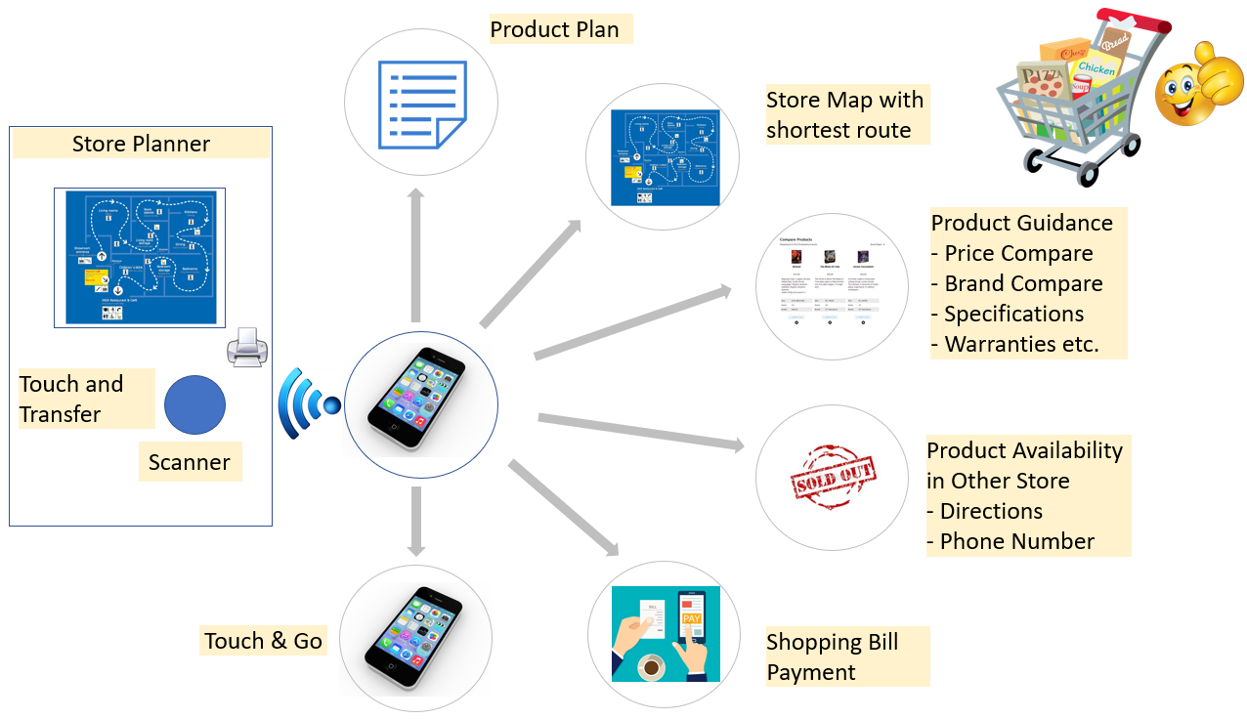

Interface for Store Managers: Interface for store managers will allow them to upload the store layout, product specifications, product inventory, product pricing (discounts, schemes and incentives etc.), product placement (aisle and bin) and landmarks within the store (pharmacy, café etc.). The interface will be a kiosk (or a surface) with a scanner and a screen. The customer can bring in a cell phone with Shop Smart App preloaded with a list of items to be purchased and touch the scanner of the kiosk. The kiosk will download the purchase list, process the data and send back a store map with a shortest path to all the locations of the items on the purchase list. The map will identify the current location of the customer and provide directions to all the locations of the items to be purchased. The kiosk will also allow the user to prepare the purchase list on its screen and transfer the map to the cell phone and or also print the map.

Smart App for Customer: The touch and transfer Shop Smart App will allow the customer to enter the user profile, payment information, list of items to be purchased and user preferences etc. As mentioned above after the store map is downloaded on to the Shop Smart App, the user can follow directions to pick up the items in the store. If the store has multiple options for an item, the Shop Smart App will provide product comparison screen to the user that will display comparison by factors such as price, discount, brand and warranty etc. After the user makes a choice and picks up an item, the user can scan the item using Shop Smart App and put it in the basket/cart and move to the next destination. After the purchases are done the Shop Smart App will provide an invoice/check to the user and request confirmation to proceed for a payment. Once the user approves the payment and the same is complete, the user can walk out of the store with the basket or cart through the door scanner which will then validate the purchase made. The Shop Smart App also allows the user to transfer downloaded store map to another cellphone.

**################################################################**

**Daniel Reeves Questions**

**1) Do you ever utilize existing shopping cart programs such as Kroger's clicklist? Y/N (modify - shopping list program / shopping list program example other than kroger )**

**2) Scale of 1-4, how often do you have to visit a different store other than the store you were initially visiting to find what you need? (modify -- stock tracking feature? Merge w/ Dajiba question below)**

**a. Never**

**b. Sometimes**

**c. Somewhat Frequently**

**d. Very Frequently**

**3) Scale of 1-5, how often do you have your personal phone with you while shopping?**

**a. Never**

**b. Sometimes**

**c. Somewhat Frequently**

**d. Very Frequently**

**e. I do not own a smartphone**

**4) Is your preferred in-store shopping method browsing all of the aisles or going straight to the items you need?**

**a. Browsing all of the aisles**

**b. Going straight to the necessary items**

**c. A mixture of both**

**################################################################**

**DAJIBA PATIL- Survey Questions**

**1. Who creates the shopping list for your shopping episode**

**a. Self b. Others**

**2. How often you miss an item from the shopping list because of unavailability**

**a.All the time b. Sometimes c.Never d. Not sure**

**3. What is your satisfaction level in getting help finding an item in the stores**

**a. Extremely Happy b. Happy c.Neutral d. Unsatisfied e. Extremely unsatisfied**

**5. On an average, how many items do you ask for help finding an item in a shopping episode**

**a. 1 items b. 2 items c. 3 items d. 4 items e.5+ items**

**6. Do you use shopping services like instacart or store's shopping services**

**a. Yes b. No. c. Never knew about it**

**7. If you answered Yes to previous question, what is the main reason you use these services**

**a. Busy schedule b. Shopping difficulties c. Others ____________**

**\*\*\*\*\*\*\*\*\*\*\*\*\*\*\*\*\*\*\*\*\*\*\*\*\*\*\*\*\*\*\*\*\*\*\*\***

**Myles Questions:**

1. **When shopping for groceries, how often do you plan to buy new items that you haven’t purchased before?**
2. **Always**
3. **Often**
4. **Sometimes**
5. **Rarely**
6. **Never**
7. **When shopping for groceries, how often do you buy new items that you haven’t purchased before once you see them in the store?**
   1. **Always**
   2. **Often**
   3. **Sometimes**
   4. **Rarely**
   5. **Never**
8. **When shopping for groceries, on average how much time do you spend searching for specific items you’re unable to locate?**

**1) Interview with Bottle King Store Manager:**

**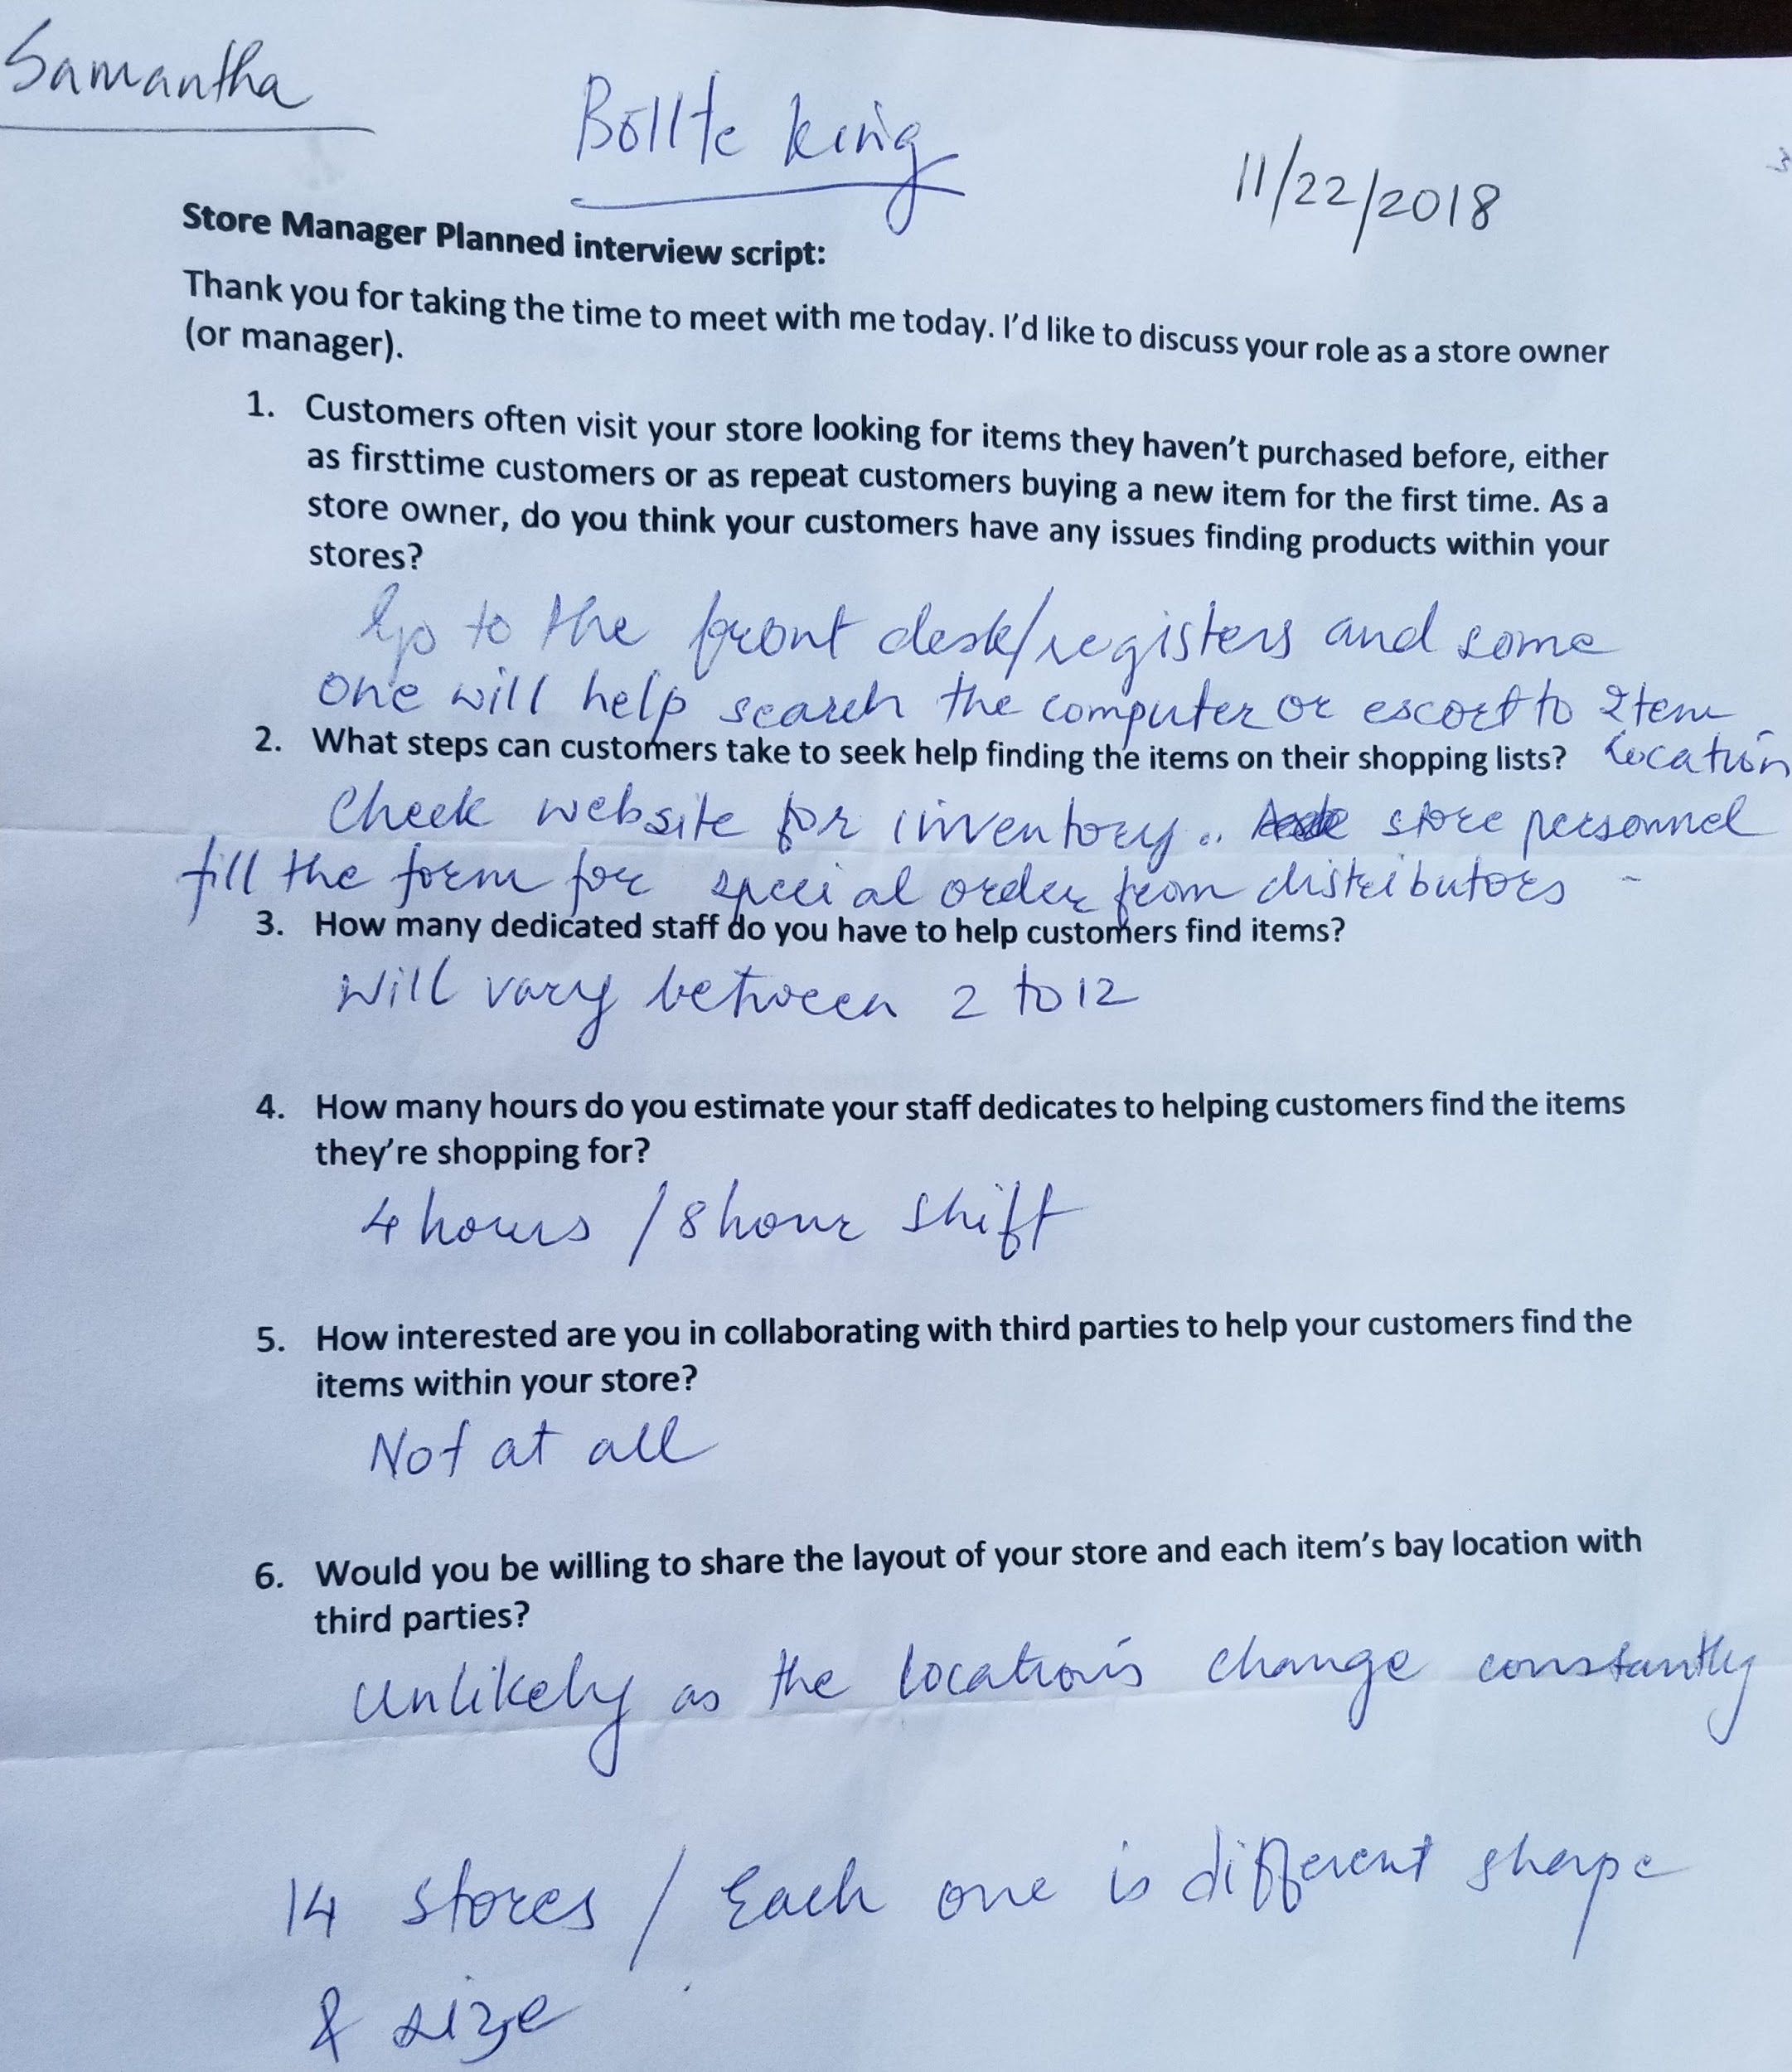  
  
  
  
  
2) Interview with Lowes Store Manager:  
   
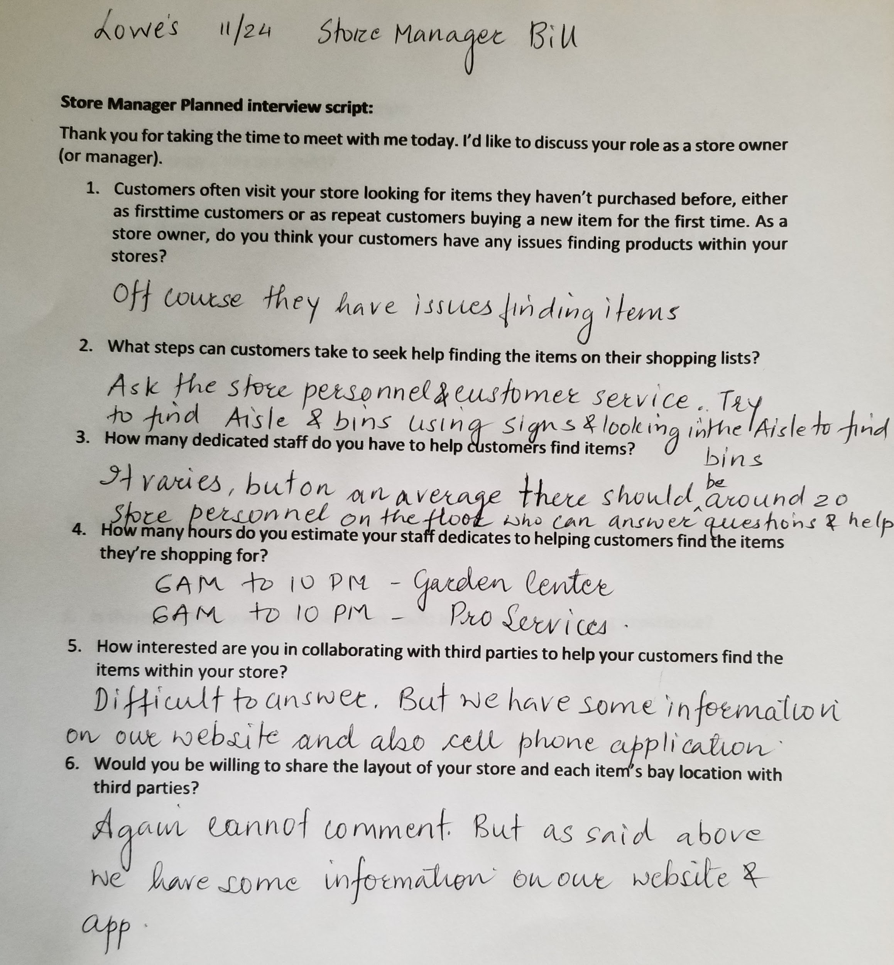**

**Shop Smart App:  
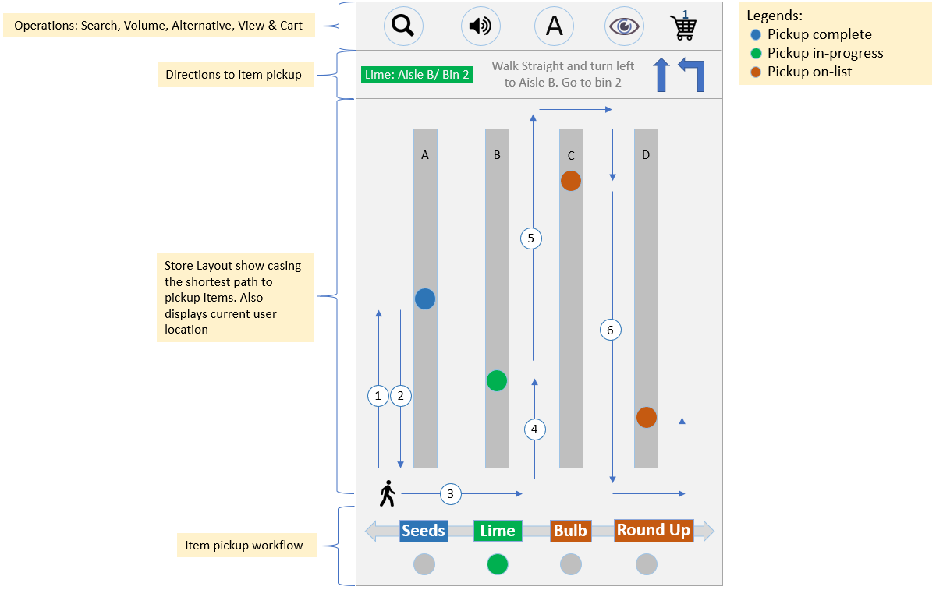  
11/25 Check In**

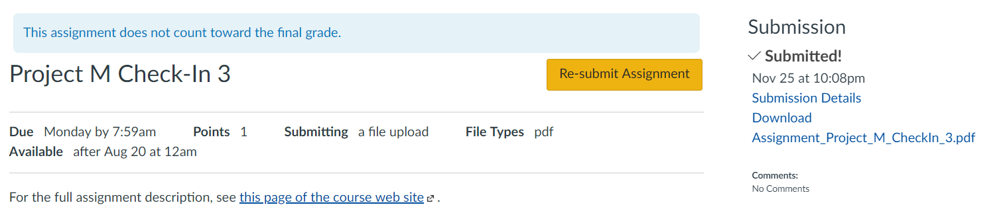

Design Alternative 2 - Shopping App for Intel Clarity Glasses/Google Glass:

This idea is inspired by using the shopping list right in the line of sight while keeping handsfree to perform other tasks such as picking up items, placing them in the cart, scanning the items purchased and paying them as the user shops. This idea is improvised version of the combination of cellphone and store api, where it leverages the cellphone to collect the shopping directions from the store api and transfer the same to the intel clarity glasses. Once the shopping list and the directions are transferred to the intel clarity glasses, they display an ordered shopping list with store directions based on the shortest path to collect these items in the lower half of the glasses. In addition to providing the shopping list and directions intel clarity glasses help to control the list e.g. once the user finds and picks up the item on the list, it “checkmarks” the item and removes the item from the list while moving the item below to the top and repeating the process. The intel clarity glasses also allow the user to control the list by gestural movements e.g. by focusing on the item on the list and turning the head slightly to the left or right will either remove the item from the list or put back the immediate deleted item on the list. The user while focusing on the shopping list can scroll through the shopping list up or down by slightly moving head up or down respectively.

The key interface components and its functionality is mentioned below.

Store API: Store API accepts the shopping list from the subscriber e.g. cellphone smart app and processes the same based on the criteria such as shortest path or customized shopping list order and throws back the shopping list and the directions to the cellphone. The API will also indicate if the item is available in store or otherwise. In case if the item is not available in the store it will provide directions as to which branch carry the same and provide branch details in orderly fashion based on the nearest distance.

Shopping App: The second key component of the interface is the Shopping app that can be downloaded and installed on the cellphone. This application will allow the user to create a shopping list. The user can send this shopping list via shopping app to the store API to process and provide e.g. shortest path to find and pick the items from the shopping list. The Shopping app sits at the center of this interface and co-ordinates with the store API and the intel clarity glasses. It takes the product information and directions from the store API and sends it to the intel clarity glasses. The intel clarity glasses also send back information to the shopping app about the product/items found, not found and removed etc. The shopping app then provides a summary of the shopping experience to the shopper.

Intel Clarity Glasses: Intel Clarity Glasses will take the shopping list and directions from the Shopping App and display the same in the lower half of the glasses. The intel clarity glasses will display top n items from the shopping list and as the shopper finds the items it will take that items from the list and put the next item on the top along with the directions. The clarity glasses will also allow the user to remove the item from the list, put back the immediately deleted item on the list, allow shopper to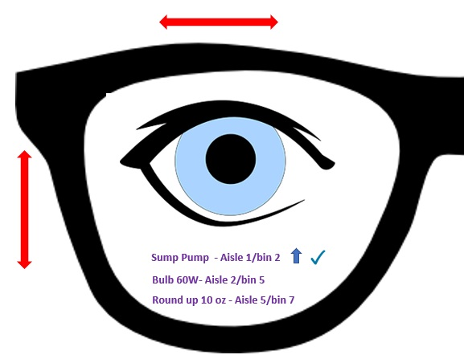 scroll up and down the shopping list and checkmark the items found and picked while shopping.

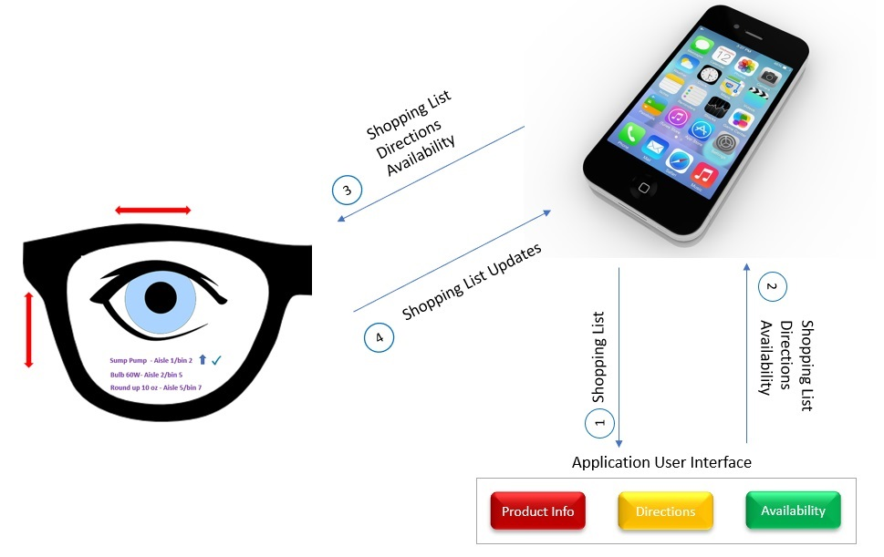

Predictive Evaluation

As part of this assignment, I will be performing a cognitive walkthrough of a redesigned model of NJ Transit Train Ticket smart app. The goal here is to navigate the app to purchase and activate the train ticket. I am assuming that the novice user (played by me) has already signed-up and provided all required information such as preferences and payment etc. The figure 3 below, shows different

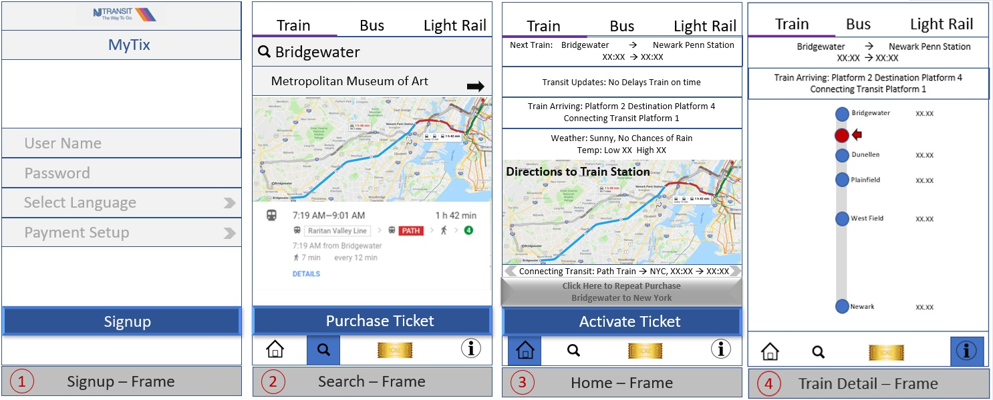

components of the redesigned interface that I will navigate such as home, search and train details, to complete the above-mentioned task.

Figure 3. Predictive Evaluation of re-designed NJ Transit Train Ticket App

Goal: Navigate the app to purchase and activate the train ticket.

Plan: As soon as I hit the home page, I see number of options such as a purchase button (this is a toggle button with Activate option) to start the purchase and activate process, navigation buttons such as search, my-tickets and train details to perform tasks e.g. search origin and destination train stations, search destination station by theme, view all the purchased tickets and view the train details. The above-mentioned options provide better discoverability to navigate and perform number of tasks without being impacted.

Specify: The home page clearly specifies what action should the user take e.g. click on the purchase button to start purchasing the ticket. Once the ticket is purchased the home page displays the activate button to activate the purchased ticket. This being a toggle button it is easier for the user to learn and perform required actions.

Perform: The moment I visit the home page, it does display the purchase button, but it would be preferable to put a signifier such as “Click here to purchase the train ticket”. This will help users who are buying the ticket for the first time, and for the regular users, if all the tickets they purchased are exhausted. This will help

minimize the gulf of execution. Clicking on the purchase button brings me to the search screen where I have options to specify origin and destination train stations or specify destination by theme (feedback). However, this screen should provide a search functionality for selecting train lines that will filter the origin and destination train stations and further minimize the gulf of execution. After entering the origin and destination train station, it immediately provides me a feedback via a map, the earliest train time and the total trip time. The screen also displays a next button. After clicking the next button, the app takes me to the screen where I can select the type and number of tickets and click on the payment button to pay for the ticket. The payment screen provides me number of options (flexibility) such as pay by credit, debit, split pay, PayPal and Apple pay. It also provides an option of default pay where it will charge the card provided during the application signup process. After I make a payment, it takes me to the mytickets screen and shows all the tickets that I purchased along with the option to activate. I can now click on the ticket activate button to activate and download the ticket. The interface allows me to visit the train details screen that shows the train path with all the stations and the current location of the train. After purchasing the ticket, the home page screen keeps track of and displays number parameters such as map, transit and weather alerts, train arrival platform, destination platform and connecting transit information. The home page provides an option to repeat (flexibility) the purchase based on previously bought tickets and provides a fast ticket purchase feature based on a default train line and payment information provided during the user sign up process.

Perceive: I was able to search, purchase and activate train ticket. After purchasing the ticket, the interface showcased all required information such as tickets purchased and activated, map, transit and weather alerts, train arrival platform, destination platform and connecting transit information etc. It also provided me an option to repeat the purchase based on the past purchases.

Interpret: Now I have all my tickets saved on my-tickets screen. I can activate these tickets before on-boarding the train. The home screen also provides driving directions to the origin train station and all required information as mentioned above.

Compare: After performing all the above actions, I can now say that my goal of purchasing and activating the train ticket has been successfully fulfilled.

Conclusion: After performing the above actions, I felt that there were few factors that may cause gulf of execution and the same can be minimized by providing appropriate signifier for a purchase button and an option to select train lines on the search page. This will minimize the gulf of execution. As part of this exercise, I realized that I has forgot to provision the “Default Train Line” setup on the signup screen that can be used for fast purchase. Besides that, the prototype provides appropriate discoverability, affordances, flexibility, feedback, learnability, comfortability and overall good representation.

